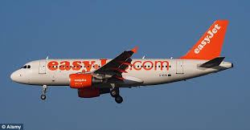
Monday: Outbound journey
- Meet at school in the sports centre car park at 5am
- Coach to Bristol airport
- 10:35am flight to Barcelona EZY 6025
- 13:40 land at El Prat de Llobregart Airport
- Coach transfer to hostel (Estimated to be at hostel at 3pm)
- Freshen up at accommodation
- 5pm: Explore local area and shops
- 7pm: Dinner at local tapas bar

Luggage:
- Students will need to bring a small carry on suitcase.
- Easyjet luggage allowance rules state: Each passenger is allowed only one piece of hand baggage on-board. The easyJet hand luggage size is 56 x 45 x 25 cm including the wheels and any handles. There is no weight limit on cabin baggage.
- No liquids over 100ml are allowed on flights. Please bring a clear sandwich bag to carry liquids under 100ml in.
- Each student will be responsible for their own passport, boarding pass, money and European Health Insurance Card.

Food and Money:
All meals (breakfast, lunch and dinner) will be provided.
Students will need some extra money (sterling and euros) for extra water/drinks, snacks and any souvenirs that they would like to purchase during the day trips.
A security deposit of 5 euros per person for the hostel. This will be returned on the final day if no damage is caused.
Accommodation: Hostel Alberg Pere Tarrés, Carrer de Numància, 149-151, 08029 Barcelona, Spain
Visits:
- Tuesday: Parc Guell, Parc Ciutadella, Picasso Museum, Maremagnum shopping centre
- Wednesday: Boquería market, Montjuic Park, Poble Espanyol, Magic Fountains
- Thursday: Camp Nou, Las Ramblas, Sagrada Familia

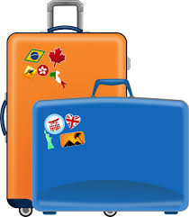
Packing list:
- Breakfast and packed lunch for the first day (travelling day)
- Suntan lotion (under 100ml) or you can buy at the airport from Superdrug regular sized.
- Hat and sunglasses
- Jumper/cardigan
- Shorts and T shirts
- Comfortable walking shoes (trainers)
- Nightclothes
- Underwear and socks
- Toiletries: toothbrush, toothpaste, deodorant under 100ml (shampoo, shower gel can be bought at airport to share in room?)
- Mobile phone and charger
- Adapters
- Beach towel
- Beach wear
- Backpack/handbag for day trips
- Money: Euros and Sterling
- Travel sickness? Medication clearly labelled and given to your group leader

Thursday: Journey Home
- 7pm: Coach to Barcelona airport
- 10:05pm: Flight to Bristol airport EZY 6030
- 11:30pm: Arrive at Bristol airport and coach to TCC
- 2:30am Estimated arrival at TCC

Contact numbers:
- On the trip KMU and ERI will have TCC mobile phones.
- Students will get these mobile phone numbers on the coach on day 1. Students will be able to contact us day or night on these numbers.
- If you need to contact a member of staff in an emergency regarding your child on the trip please contact the Headteacher via school reception during school hours. Outside of school hours in an EMERGENCY we will give you the Headteacher’s school mobile number via a letter the week before the trip.
Friday: At TCC
- 12pm start in school
- No students are allowed in school before 12pm.
- The afternoon will be spent writing up a report of the trip and making a display with photos.
- Please bring in a packed lunch.

